**CN lab task12**

# 

***(Computer Networking Lab )***

**Muhammad Babar ALI**

*( SU92-BSSEM-F22-065 )*

BSSE – 5B ( 2022 – 2026)

**Department Of Software Engineering**

Submitted to: Sir Rasikh ali

Submitted on: Dec 10,2024

**Faculty Of CS&IT ( Gold Campus ), Superior University, Lahore**

**Question:**

**VLAN:**

* Divides a physical network into multiple virtual networks.
* Each VLAN forms its own broadcast domain, isolating traffic.
* Operates at Layer 2 of the OSI model, dealing with MAC addresses.
* Devices in different VLANs cannot communicate directly.

**Example:**

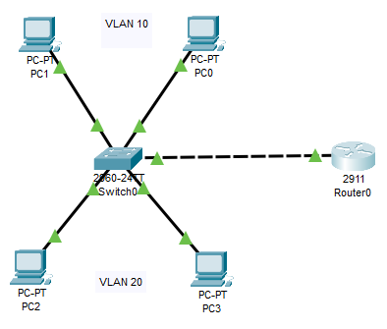

**Inter-VLAN:**

* Allows devices in different VLANs to communicate with each other.
* Requires a Layer 3 device (router or Layer 3 switch) to route traffic.
* Uses routing protocols like OSPF or RIP to establish routing between VLANs.
* Each VLAN is assigned an IP address, enabling routing between them.

**Example:**

